Jupyter Notebook

Safa Abusaba

May 19 2019

# My Jupyter Notebook on IBM Data Science Experience

**Safa Abusaba**

*I am interested in data science to enhance my ability in the healthcare field*

*This is my first markdown document.*

Here is some extra examples:

1. <https://www.linkedin.com/in/safa-abu-saba-425a1562/>

* Bullet point example
* Logo alt text

### Below, I am practising to load some data and vizualize it as a further demonstration

library(datasets)  
data(airquality)  
summary(airquality)

## Ozone Solar.R Wind Temp   
## Min. : 1.00 Min. : 7.0 Min. : 1.700 Min. :56.00   
## 1st Qu.: 18.00 1st Qu.:115.8 1st Qu.: 7.400 1st Qu.:72.00   
## Median : 31.50 Median :205.0 Median : 9.700 Median :79.00   
## Mean : 42.13 Mean :185.9 Mean : 9.958 Mean :77.88   
## 3rd Qu.: 63.25 3rd Qu.:258.8 3rd Qu.:11.500 3rd Qu.:85.00   
## Max. :168.00 Max. :334.0 Max. :20.700 Max. :97.00   
## NA's :37 NA's :7   
## Month Day   
## Min. :5.000 Min. : 1.0   
## 1st Qu.:6.000 1st Qu.: 8.0   
## Median :7.000 Median :16.0   
## Mean :6.993 Mean :15.8   
## 3rd Qu.:8.000 3rd Qu.:23.0   
## Max. :9.000 Max. :31.0   
##

Here is a pairs plot.

pairs(airquality)

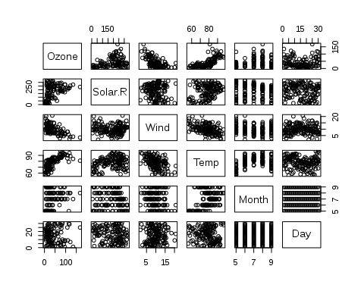

## Here is a regression model of Ozone on some predictors##:

fit <- lm(Ozone ~ Wind + Temp, data = airquality)  
summary(fit)

##   
## Call:  
## lm(formula = Ozone ~ Wind + Temp, data = airquality)  
##   
## Residuals:  
## Min 1Q Median 3Q Max   
## -41.251 -13.695 -2.856 11.390 100.367   
##   
## Coefficients:  
## Estimate Std. Error t value Pr(>|t|)   
## (Intercept) -71.0332 23.5780 -3.013 0.0032 **   
## Wind -3.0555 0.6633 -4.607 1.08e-05 ***  
## Temp 1.8402 0.2500 7.362 3.15e-11 ***  
## ---  
## Signif. codes: 0 '***' 0.001 '**' 0.01 '*' 0.05 '.' 0.1 ' ' 1  
##   
## Residual standard error: 21.85 on 113 degrees of freedom  
## (37 observations deleted due to missingness)  
## Multiple R-squared: 0.5687, Adjusted R-squared: 0.5611   
## F-statistic: 74.5 on 2 and 113 DF, p-value: < 2.2e-16

**Thank you!!**